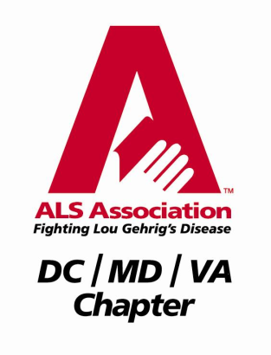
Dave Simmons 3RD ANNUAL ALS Golf Tournament
Saturday - May 10, 2014 –11-12 Registration 12:30 Tee Off –
Rain or Shine (No Refunds)
Wetlands Golf Course, Aberdeen, Maryland

$125 Per Player
All Proceeds Benefit ALS Research – Receipt for Tax Deduction Provided by ALS Association

PLAYER FEE INCLUDES
Registration: 11:00 AM-12:00 PM – Hot Dog, Chips, Beverage Lunch, Range Balls

Shotgun Start: 12:30 PM
(Beer, Soda, Snacks on Course)

Dinner following the Tournament – Non-Golfing Dinner Guests May Join You for $30.00 Additional

Prizes for:
1st, 2nd and 3rd Place
Closest to the Pin, Putting Contest, Hole-in-One Prize Tee and More!

For more information contact:
Peg Goodson at thepegg@comcast.net (410-588-5829) or
Dave Cooper at dcoop1949@yahoo.com (410-569-0569)

Visit our Event, Dave Simmons ALS Golf Tournament, on Facebook

Checks made out to: ALS Association – DC/MD/VA Chapter
OR
Register and Pay by Credit Card - Visit our Website davesimmonsalsgolftournament.weebly.com!
Print Clearly, Tear Off and Return by April 24, 2014 to:
Peg Goodson, 16 Glen Gate Court, Bel Air, MD 21014

Team Captain/
Individual: _________________________________ Amount Paid: $______________

Address: _______________________________ Phone:_____________________

City, State, Zip: __________________________________Phone:_____________________

Team Captain/Individual E-Mail Address:__________________________________________

Team Members: __________________________________Phone:_____________________

__________________________________Phone:_____________________

__________________________________Phone:_____________________
REGISTER AND PAY BY April 24, 2014 AND BE ENTERED INTO A SPECIAL DRAWING AT THE TOURNAMENT DINNER!
SIGN UP A PAYING GOLFER BRAND NEW TO THE TOURNAMENT AND RECEIVE 10 FREE RAFFLE TICKETS FOR OUR TOURNAMENT GIFT BASKETS!

