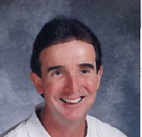
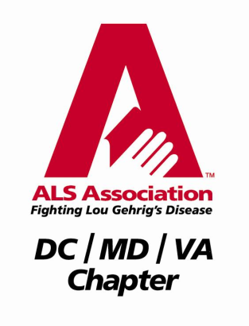
Dave Simmons ALS Golf Tournament

Friends of Dave Simmons have gathered to organize the Dave Simmons ALS Golf Tournament at the Wetlands Golf Club in Aberdeen on May 10, 2014. To date, with your generous support, we have gifted over $22,000 for ALS research and we hope you will join us this year as we continue the battle to find a cure for ALS.

All proceeds from this year’s event will benefit ALS research in memory of Dave Simmons, a former physical education teacher with 35 years of exemplary teaching and coaching experience with Harford County Public Schools. Dave touched many children’s lives teaching students from kindergarten through twelfth grade during his career. Often initiating innovative elementary curriculum like bowling and the Olympics as well as giving of himself for others with programs like Jump Rope for Heart, he is remembered as a role model for students and adults alike in the school system as well as his church and neighborhood communities. Dave is credited with the origination of the football program at Harford Technical High School and coached baseball, soccer, and football. His work with the First Tee program brought the sport of golf to underprivileged children. It is expected that Dave will soon be honored by being inducted into the Educators’ Hall of Fame for Harford County Public Schools.

ALS – or Amyotrophic Lateral Sclerosis - is a progressive neurodegenerative disease affecting nerve cells in the brain and the spinal cord. Also known as Lou Gehrig’s Disease, it most commonly strikes our friends and family members between the ages of 40 and 70. As many as 30,000 Americans are living with this debilitating disease at any given time. Currently, there is no known cure for ALS. With your support, we are joining with the ALS Association to fund research that will lead to a treatment and ultimately a cure. Last year’s tournament sponsors and golfers participated not only for Dave and in his memory, but for loved ones who are battling ALS or have also lost their battle with this disease.

The Dave Simmons ALS Golf Tournament will be held on May 10, 2014, rain or shine, with a 12:30 shotgun start beginning an afternoon of golf and culminating with a sumptuous dinner and the awarding of prizes.

All contributions will be registered with the local ALS Association chapter (tax exempt no. 52-1749047), and a receipt will be provided for tax purposes.

If you have questions about the event, or wish to discuss the event with organizers, please contact Peg Goodson at thepegg@comcast.net (410-588-5829) or Dave Cooper at dcoop1949@yahoo.com
(410-569-0569).

We thank you for your contribution and support,
Friends of Dave Simmons ALS Golf Tournament Committee

Visit us on our website: davesimmonsalsgolftournament.weebly.com or
Visit our Event, Dave Simmons ALS Golf Tournament, on Facebook

Dave Simmons ALS Golf Tournament

May 10, 2014, 11-12 Registration 12:30 Tee Off, Rain or Shine,
No Refunds
Wetlands Golf Course, Aberdeen, Maryland

Sponsorship Opportunities

Title Sponsor Contribution $1,500
Includes your name on all tournament communication, sponsorship sign at registration table, foursome in the tournament

Lunch or Contribution $500
Dinner Sponsor Sponsorship sign at dining area

Beverage Sponsor Contribution $300
Sponsorship on beverage cart

Golf Tee Sponsor Minimum Contribution
Whole Tee $100.00
Half Tee $ 50.00
Quarter Tee $ 25.00
Fifth Tee $ 20.00
Name displayed at tee box for one specific tee

Gift Sponsor Gift Certificates to your business

Donation Sponsors
Carry-home bags, tees, golf towels, golf balls, snack items, cash donations to purchase bag items

Visit us on our website: davesimmonsalsgolftournament.weebly.com or
Visit our Event, Dave Simmons ALS Golf Tournament, on Facebook

